## Prelim Pages

Version Control /Approval etc

## Introduction

Correct updating of custom forms is paramount to reduced maintenance requirements.

A range of user forms were generated to improve the interface when being used. Most of the coded solutions take advantage of object containerships within the constraints of the programming language and environment.

## Target Audience

This document assumes prior experience with programming in VB and specifically VBA for Excel. Users who are not familiar should undertake research or a course on the VB/VBA before attempting to do any maintenance on the forms.

## Containership Example

Figure 1 below demonstrates the use of a VB Container called a “Frame” to contain or hold a series of other objects of interest. The frame was named **frData** and code uses this container to locate only the contained objects.

Further filtering uses the visible property to exclude invisible objects from the processing loop. This approach is highly flexible and allows updates to the forms without consideration to the coding.

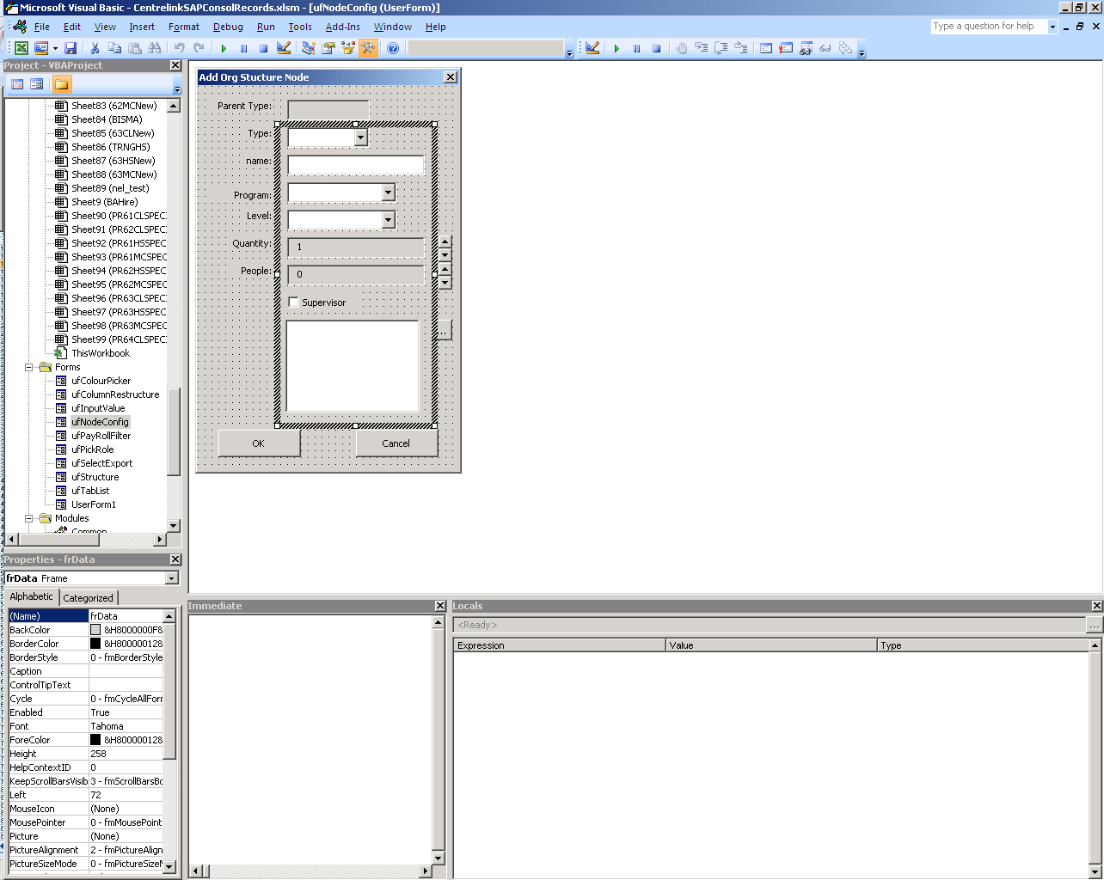

Figure

## Coded Solution

Figure 2 below shows the code that works with the form in Figure 1 above is a function that has to determine if the user selected cancel or OK, and return a usable string based on the control names and values. This specific case generates a string value with each visible control for use by the XML control file. The form is named **ufNodeConfig** (uf = User Form) to differentiate from other objects which is in line with MSDN recommendations for VB coding standards.

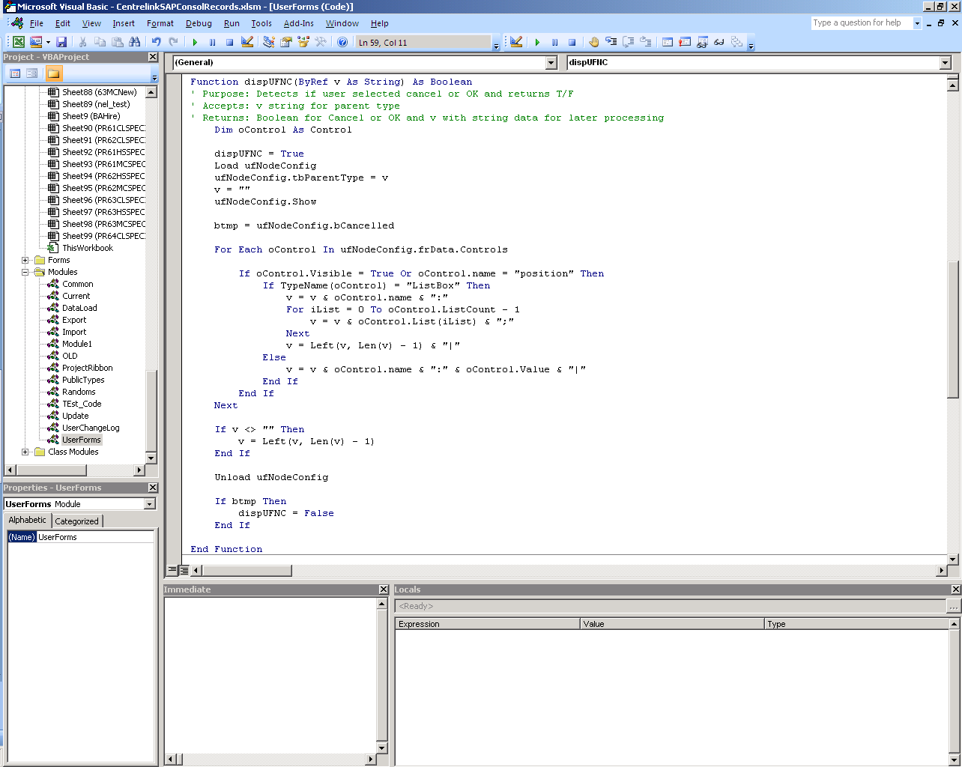

Figure

In the middle section (For Each) is the processing loop which processes by:

* Filtering on Visible or Name Property values (ignores invisible items or not named “position”)
* TypeName for listboxes, add control name and generate a semicolon separated list for each value;
* Other controls - add control name and value;
* Trim the string to remove trailing semicolons or pipe characters;

This method provides a maintenance free coding solution that is not affected by adding new or removing old controls within the target frame or container.

...oooOOOooo...